 | INTERNATIONAL TELECOMMUNICATION UNION |  |  |  | COM 13 – C 548 – E
 | TELECOMMUNICATION  STANDARDIZATION SECTOR  STUDY PERIOD 2009-2012 |  |  | April 2010
English only
Original: English
Question(s): |  | 12/13
STUDY GROUP 13 – CONTRIBUTION 548
Source: |  | ETRI
Title: |  | Discussion on common functionalities according to service classification in Y.NGN-Web
1. Introduction
At the last NGN-GSI meeting on January 2010, we had discussed NGN architecture with web service component in Y.NGN-Web (Functional Requirements and Architecture of Web Service Component in NGN). In particular, several issues on common functionalities had been raised at the joint session with Q5. Accordingly, the related editor’s note had been included in the Section 7.2 of Y.NGN-Web as follows.
(Editor’s Note) Further study on common functionalities in four service components is required.
So, this contribution discusses further study issues for common functionalities for service control according to service classification.
2. Discussion
2.1. Service classification in Y.NGN-Web
NGN should support multi-service capabilities which support various composition services simultaneously. The network requires networking environment with NGN/Web convergence.
According to different service control, NGN services can be classified as follows.
- Web services
  - Pure web services using web service component (traditional Internet service)
- Web-based services
  - Web-based conversational services (e.g., Web + VoIP)
    - Web-based call services using interworking with IP multimedia service component or PSTN/ISDN emulation service component
  - Web-based streaming services (e.g., Web + IPTV)
    - Web-based IPTV services using interworking with IPTV service component and/or IP multimedia service component
  - Web-based composition services (e.g., Web + VoIP + IPTV)
    - Blending services both Web service component and interworking with other service components
2.2. Common functionalities for service control
For service control for various services, Figure 1 show relationships with service components in service control functions of NGN service stratum depending on service types which is classified in the previous section.
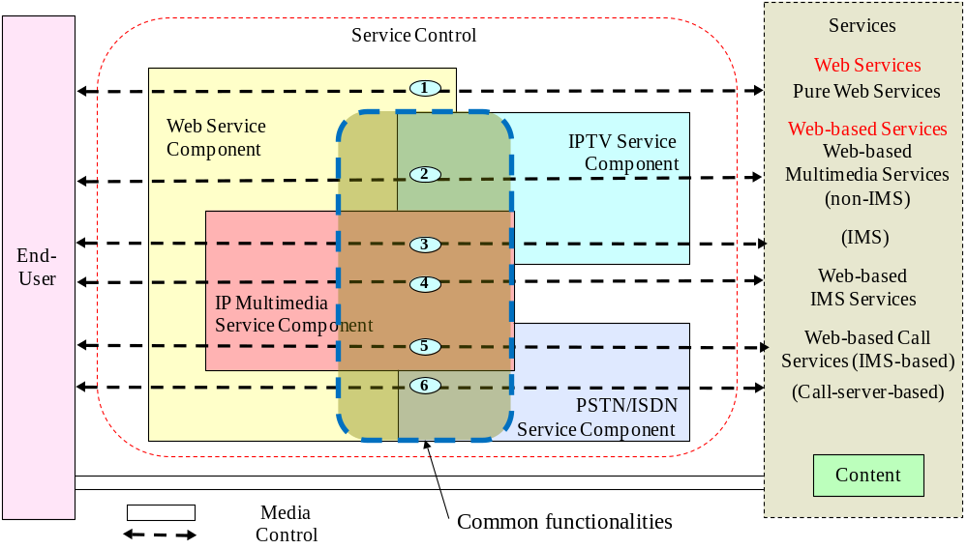
Figure 1. Service classification according to different service control
In Figure 1, there are 6 cases among different service components.
- Case 1: Web service component
- Case 2: Web service component + IPTV service component
- Case 3: Web service component + IP multimedia service component + IPTV service component
- Case 4: Web service component + IP multimedia service component
- Case 5: Web service component + IP multimedia service component + PSTN/ISDN service component
- Case 6: Web service component + PSTN/ISDN service component
For further work, we need to clearly identify common functionalities after comparing existing NGN functionalities and find relationships among other functions.

3. Proposal
After discussion, we would like to replace the previous figure (Figure 2) in Y.NGN-Web by the figure in this contribution and include related descriptions in order to indicate common functionalities more clearly. In addition, the related contributions for identifying common functionalities are requested for further progress of Y.NGN-Web.
________________

